The twenty-second edition of the Prinsjesdag National Foal Auction took place on Tuesday 16 September at the National Equestrian Centre in Ermelo. Also this year a newsletter is sent to all participants and other interested persons.

Prinsjesdag Foal Auction better again!
After the record sales of the 2013 Prinsjesdag National Foal Auction (NVP), when for the first time the foals and embryo’s fetched over a million euro, this year’s NVP again broke records. The total sales of 105 foals and embryo’s amounted to € 1,077,500. The average price was well above € 10,500. Presently, all the foals and embryo’s have
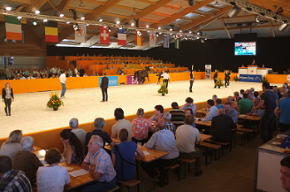
(The new Amalia hall in Prinsjesdag colours)

been paid to Foundation NVP and eventually the better part of the stock has been delivered, so most breeders have been paid already. Of the 105 auction items, 36 were sold abroad, that is 34.3%. This is a little more than the 30% in 2013. As far as that is concerned, the N of National should perhaps be replaced by a I for International in the name of Prinsjesdag National Foal Auction. Of the interest shown from abroad, Belgium was leader with nine purchases, but also Germany with eight, Greece with four, the United States with three and Peru with two were doing their best. Other buying countries at the NVP were Sweden, Italy, France, Kuwait, Austria, Great Britain, Spain, Mexico and the United Arab Emirates.

This year for the first time the NVP auction took place in the new Amalia hall of the

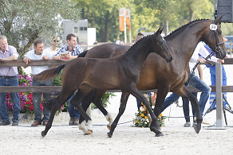
(outdoor presentation)

National Equestrian Centre in Ermelo. One of the new features was the breeders stands located directly at the ringside, where the participants of the auction could follow the proceedings in the ring in full comfort. The division into dressage and show jumping foals and the presentation of the foals outdoors in the afternoon were first tested in 2013 and, having been a success, this format was also applied in 2014.

Goodbye to chairman Herman Verhagen
Part of the evening programme was saying goodbye to Herman Verhagen, who has been chairman of the NVP Foundations for more than 15 years. Multiple world champion four-in-hand IJsbrand Chardon gave a special

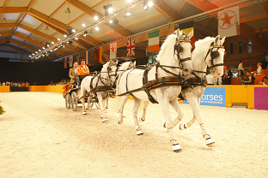
(IJsbrand Chardon and departing chairman Herman Verhagen)

performance for the occasion. With his four

greys Chardon put down a spectacular show and at a later date he will teach the former chairman the tricks of the driving trade at a clinic. The successor of Herman Verhagen is Arjan van der Waaij from Eemnes.

Fine returns for DVB Foundation
Also this year NVP auctioned stud services for the DVB Foundation, the Foundation of the Olympic lady riders Coby and Marlies van Baalen for the benefit of handicapped riders.
The service of performance test champion Giovanni (standing at Gert-Jan van Olst) was bought by Stal Jacatra BV from Henk Bruijns. The service of Glock’s London (Nabab de Rève x Chin Chin) was acquired by an equally loyal supporter of Prinsjesdag National Foal Auction: Rinus Blom from Etten-Leur.

VDL, NVP-breeder of the year wins again!
At the Prinsjesdag National Foal Auction on 16 September the Van de Lageweg family from Friesland won the title of NVP-breeder of the year. This was because of the golden team medal of the Dutch showjumping team in which VDL Bubalu under Jur Vrieling had played a crucial role. After their victory in Normandy, France, Vrieling and VDL Bubalu also won the Furusiyya Nations Cup Finals

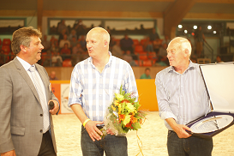
(Chairman Arjan v/d Waaij, Wiebe-Yde and Wiepke v/d Lageweg)

with the team. The last round of VDL Bubalu in Barcelona, who will say goodbye to the international top sport next spring, turned out nothing short of a dream. He and Vrieling were determined to keep their slate clean and so helped the Netherlands to its first victory since the birth of the Nations Cup.
Although Bubalu’s retirement is planned, Jur Vrieling will not be without a horse. In recent years VDL Zirocco Blue has been expertly trained by the rider from Holwierde, which resulted in victory in the World Cup in Oslo and one week later a fourth place in Helsinki.
The Van de Lageweg family earned their title of NVP-breeder of the year thanks to the successes in the international sport and breeding. Besides, VDL-Stud is a loyal participant of NVP. This year VDL sold a filly by Carrera VDL out of the Corland daughter Zersina to Stal Brouwershof from Limburg.

Entering foals
If you are a breeder and are interested in having a foal auctioned at next year’s Prinsjesdag National Foal Auction, you can inform us already of your intention. If you mail us the pedigree of your mare and as much as possible relevant information about the sport performance of the dam’s family, stating which stallion your mare was covered with, we will let you know if we are possibly interested for our 2015 NVP edition. You can mail this information to: info@veulenveilingprinsjesdag.nl.

More information:

w: www.veulenveilingprinsjesdag.nl
e: info@veulenveilingprinsjesdag.nl
f: www.facebook.com/veulenveilingprinsjesdag

In case you do NOT want to receive this Newsletter any longer, please send a return email to this address.

